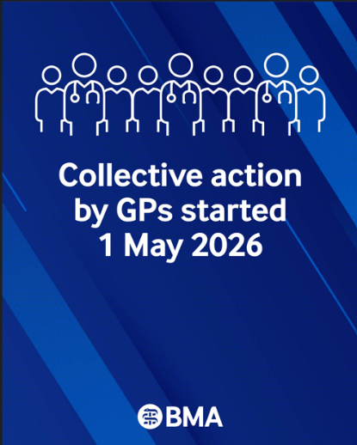
Dear colleagues

Collective action against new GP contract
As of 1 May, we are urging GP partners and practices to take part in collective action, given Government’s insufficient assurances regarding our concerns over the 2026/27 GP contract. Practices are working in crisis-level environments, where every day feels ‘exceptional’ in terms of unlimited demand outstripping available workforce capacity. Being placed in a position where delivering an imposed contract is an impossibility for too many, with the subsequent rationing of care, is unreasonable and unsafe.

Therefore, GPC England is recommending one single action for May, focusing on the flow of GP patient data outside practices, in the form of practice data sharing agreements (DSAs).

- This action may reduce the liabilities on a partnership. The letter has been reviewed by BMA Law and an external leading KC Counsel – it is lawful, and it is not defamatory.
- We foresee that it will be welcomed by the public, keen for greater transparency that will strengthen the trust between GPs and patients.
- Nevertheless, it will impact integrated care systems and the wider NHS Government agenda which is increasingly seeing a ‘left shift’ of work from hospitals into practices, without any commensurate resource to meet the challenge.

Why this Action letter?

- This is the first letter in a sequence, so you need to embed this foundation enquiry stage, in order to be able to ‘up the ante’ next month, should Government fail to provide sufficient concessions to the imposed 2026/27 GMS contract.

- This letter highlights to DHSC/NHSE and ICBs the extent that our GP patient data is relied upon. We recognise that ICBs may have ‘bundled together’ numbers of DSAs historically, and this provides an opportunity for ICBs to prove that their records are accurate, given the recent system architecture changes.

- It provides partnerships and practices with a ‘housekeeping’ opportunity to ensure the practice is fully up to date, and that all active DSAs have all necessary DPIAs are in place from an information governance perspective.

- ICBs rely on GP partners, who over decades have created arguably the most valuable longitudinal data set in the western world, to share their data – often for no financial return at all. This places Partnerships in a strong leverage position, especially if it should come to light that system processes have been lacking, e.g. in guaranteeing the care for patients who have opted-out of data sharing will not be affected.

- It shows the rest of the NHS how practice partnerships hold considerable power and influence in the success or failure of the current NHS, its neighbourhood planning, and the Government’s priorities to use GP patient data in the Single Care Record. We are anticipating that this will become prominent and newsworthy next week in the Health Bill to be announced in the King’s Speech to the State Opening of Parliament on Wednesday 13 May.

- It demonstrates that our c6,250 practices are willing to act en masse with the BMA to up the ante and use this leverage to secure concessions to the GMS contract. Should ICBs default to a weak standardised DHSC/NHSE drafted response, this may demonstrate incompetence and potential concern that they have failed to take the necessary and lawful steps which are their duty as the data processor.

- Remember – this is a private request from a practice to its commissioner. It isn’t going to be published anywhere, but should practices receive inadequate responses in their 1000s, then that likely will become a headline the BMA can use with the mainstream press to demonstrate the lack of suitability of the Government to potentially wrest control of patient data from GP Partners in the future. All the while, the Practice Partnership is demonstrating its understanding of its duties as Data Controller for the GP Record, and its sound governance.

- If you have active DSAs in place, you may want to know exactly where your GP patient data is going, and for what purpose – your patients also deserve to know in line with their rights within GDPR.

Action for practices:

1. Send the template letter to your local ICB, indicating you will stop agreeing to voluntary secondary uses data sharing agreements (DSAs) from May 2026.

We appreciate the vulnerable position that practices are in and have sought a legal view to ensure that the wording in the letter ensures that practices continue to be compliant with requirements placed on them by the ICB and NHSE. You are of course free to amend as you see fit and your LMC may be able to assist in this, but it is neither unlawful nor defamatory so please be assured.

2. Refer any new DSA requests to BMA via gpcontract@bma.org.uk

3. Carry out an audit of all existing DSAs that your practice is currently signed up to – see our guidance on easy-to-follow screenshots for all GP systems

4. Initiate a conversation within your practice and PCN ahead of your patient participation groups (PPG).

We have also prepared the following resources to help practices understand the bigger picture, become more informed and to increase understanding in why all practices need to take part in this collective action:

- Focus on GP data control
- PC ITs screenshot guide for reviewing DSAs within your GP system
- The Government’s plan for the Single Care Record (SCR) – a briefing note for GPs
- Why GP collective action is focusing on data transparency
- LLR LMC case study - an example of how LMC led local collective action to cease data sharing requirements led to success across one ICB.
- FAQs: GPC England Collective Action letter Regarding DSAs

Access all resources on How to take part in GP collective action in England

Taking part in this action will both help your practice stay safe and put further pressure on the Government to build on the progress made and secure safeguards for practices to be able to deliver their GMS contract safely. The proposed collective action for May does not breach your contract and is a straightforward and simple initial step to follow. You do not need to be BMA members to send this letter, so please share across your PCN and locality to secure collective action.

We will be seeking to continue negotiations with Government in the weeks ahead. GPC England meets on Thursday 21 May, which provides another opportunity for Government to de-escalate collective action and heed our genuine concerns to safeguard practices going forward.

Access our latest guidance on our campaign page

Contract changes 2026/27 - guidance
Following the imposed contract changes on 1 April, we would recommend that practices review and prepare for the implementation of the 2026/27 contract. See our lates guidance:
- Local variation on PCN DES
- Focus on Advice and Guidance and SPoA - April 2026
- Focus On the New 26-27 GP Employment Reimbursement Scheme
- DDRB FAQ 2026-27
For more information, please view our GP Contract and campaign page with the latest updates and guidance about the 26/27 contract changes and our dispute with Government, to help support you and your practices.

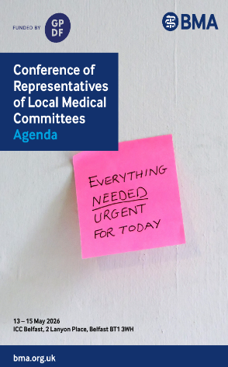
LMC UK Conference 2026

The LMC UK Conference 2026 will be held next week, 13-15 May 2026, at the ICC Belfast.
The Conference Agenda has been published and the conference will be live streamed.

Further information is available >

Your GPCs and their dispensing negotiations
The Dispensing Doctors Association (DDA) has published a podcast, where GPC England chair Dr Katie Bramall joins Scottish and Welsh colleagues Al Miles and Ian Harris speaking to the DDA about their progress towards achieving a sustainable dispensing contract in Wales, Scotland and England.

Listen to the podcast here: Your GPCs and their dispensing negotiations

RCGP petition more GPs for continuity of care

Take a simple but powerful step: sign our UK Parliament petition calling on Government to make the NHS easier for patients and GPs to navigate. The RCGP joint report with the Patients Association revealed many patients struggle to know where to turn, track referrals, or understand their care pathways. This is a systemic issue requiring system-wide change. This petition calls for clearer pathways, timely information, and better access to general practice. Sign and share this petition to help turn evidence into action: https://petition.parliament.uk/petitions/762586

Rebuild General Practice petition

General practice is the front door to the NHS — but it is under increasing pressure. Patients are finding it harder to access care, and GPs are struggling to provide the continuity and quality of care they were trained to deliver.

Rebuild General Practice has launched a petition calling on government to restore capacity, protect continuity of care, and secure the future of the family doctor model. You can sign the petition here
- The BMA’s GP campaign webpage
- GPCE Safe Working Guidance Handbook
- Read more about the work of GPC England and practical guidance for GP practices
- See the latest update on X @BMA_GP and read about BMA in the media

GPCE bulletin: Collective action against new GP contract | contract changes guidance | LMC UK conference

Dr Katie Bramall
GPC England chair

Email: info.lmcqueries@bma.org.uk (for LMC queries)
Email: info.gpc@bma.org.uk (for GPs and practices)

